

MOTION DETECTOR
ON/OFF
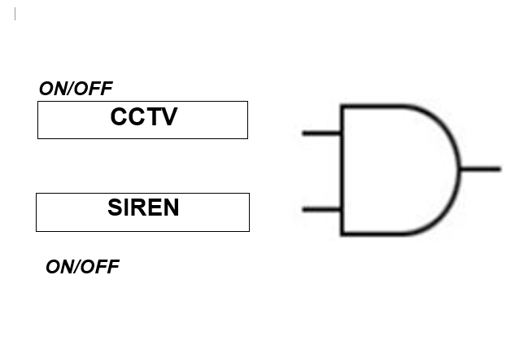


If both the CCTV and the Siren are on (1) then the Motion Detector is activated

